MacStoreNepal

Issue: Admin Can Update an Order Using Stale Data Until the Page Is Refreshed
Module
- Customer Order Management
- Admin Order Management
Issue Type
- Data Consistency Issue
- Stale Data Issue
- Concurrency Issue
Description
When an admin opens the Orders page, the order information is loaded and displayed. If a customer cancels an order afterward, the admin page continues to display the previous order status until the page is manually refreshed.
Because the admin is viewing stale data, the order can still be updated to another status (such as Processing) before the latest order state is loaded.
Once the admin refreshes the page, the updated order status (Cancelled) is displayed correctly, and the system prevents further editing of the order.
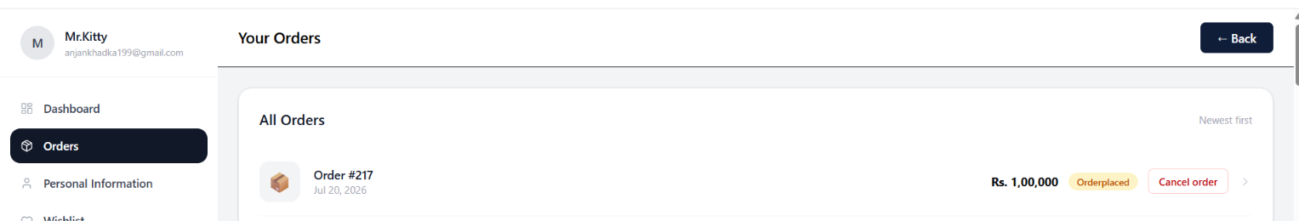
Fig: Orders Section
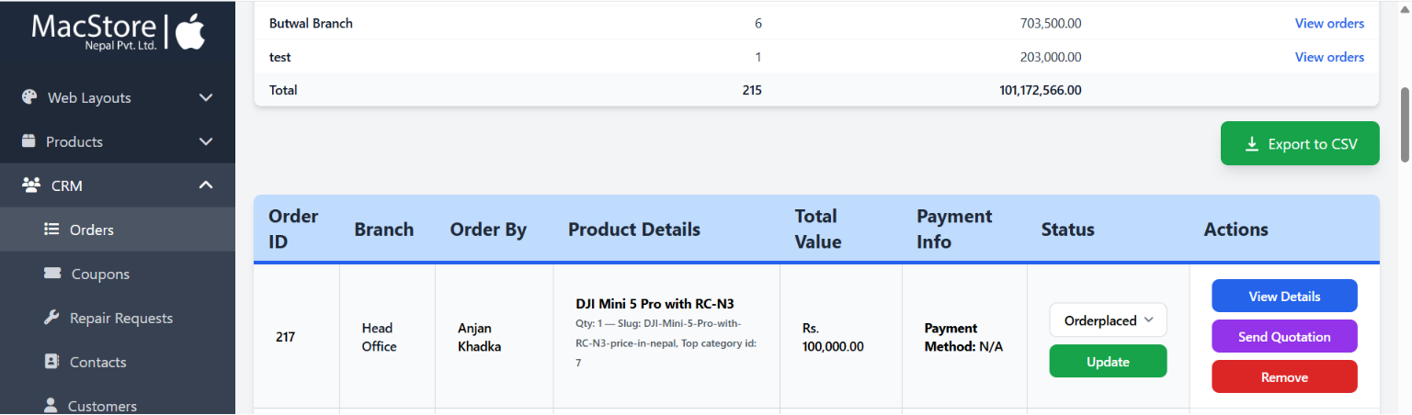
Fig: Customer Order Management
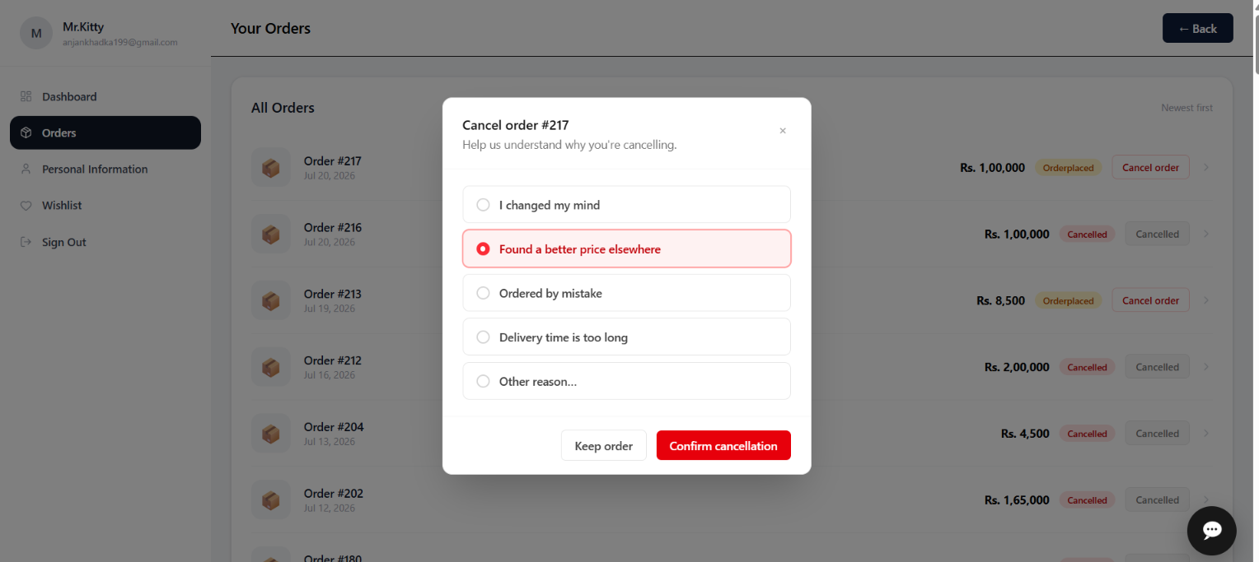
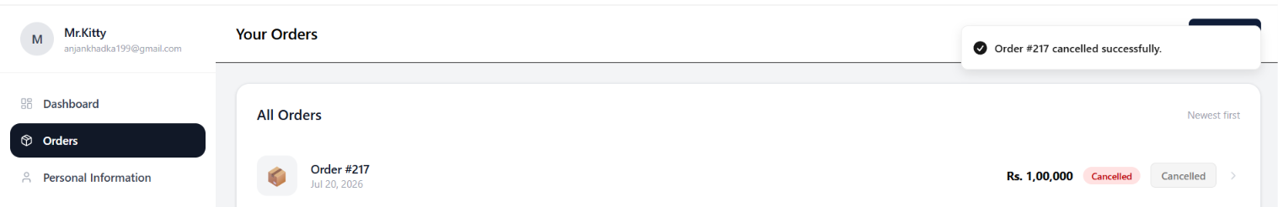
Fig: Canceling the Order
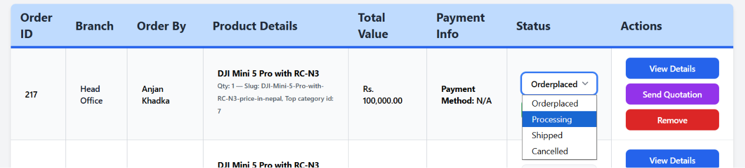
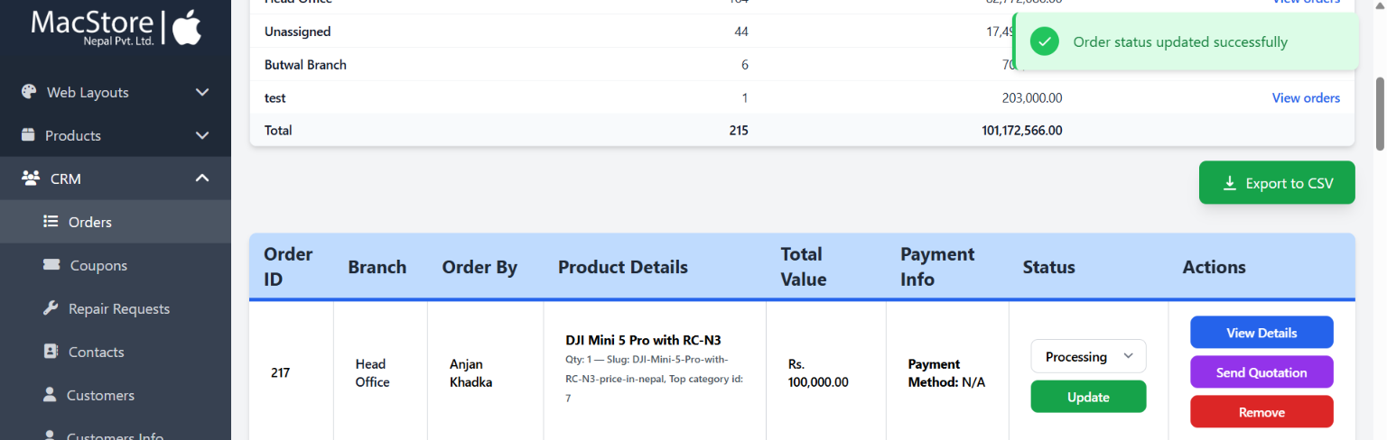
Fig: Updating the Order Status to processing without page refresh
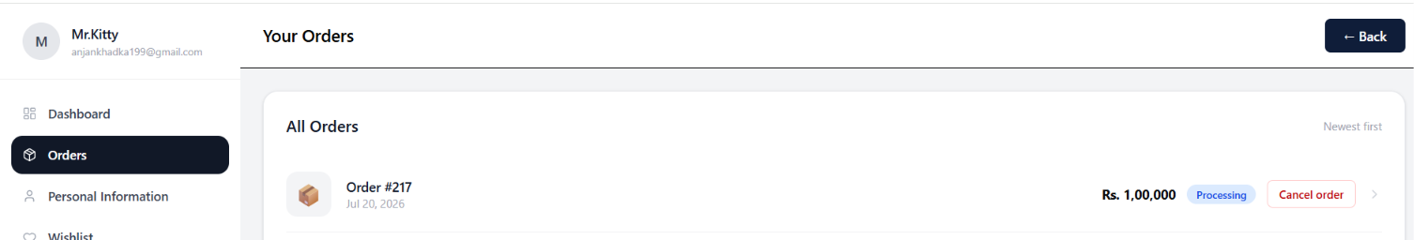
Fig: Customer Seeing processing order status for cancelled order
Steps to Reproduce:
- Customer places an order (e.g., Order #217).
- Admin opens the Orders page.
- Customer cancels Order #217 from the customer portal.
- Without refreshing the admin page, attempt to change the order status to Processing.
- The status update is accepted.
- Refresh the admin page.
Expected Result:
If an order has already been cancelled by the customer, the admin should not be able to update its status, even if the admin page has not been refreshed.
The system should validate the latest order status before processing the update and display a message such as:
"This order has already been cancelled. Please refresh the page."
Actual Result:
The admin can update the order using stale data. Only after refreshing the page does the admin interface display the cancelled status and disable editing.
Root Cause:
The admin interface displays previously loaded data until a manual refresh occurs. The latest order status is not synchronized with the admin view in real time, allowing actions to be performed based on outdated information.
Impact:
- Order status can temporarily become inconsistent.
- Cancelled orders may be updated to another processing stage.
- Admins may unknowingly perform actions on orders that are no longer eligible for processing.
- This can lead to operational confusion and incorrect order handling.
Recommended Solution:
- Before updating an order, verify the latest order status from the database.
- Reject the update if the order has already been cancelled.
- Display a clear message to the admin indicating that the order status has changed and the page should be refreshed.
- ……………….
Note: Backend validation before update

Issue: Deleted Products Continue to Appear in Assigned Accessories
Module
Product Management / Product Accessories
Issue Type
- Data Integrity Issue
- Referential Integrity Issue
- Orphaned Relationship
Description
The system allows an administrator to assign a newly created product as an accessory to another product during product creation. The product is created successfully, and the accessory relationship is also stored successfully.
However, when the accessory product is deleted from the Product Management module, the product is removed from the product list as expected, but it continues to appear in the accessories assigned to other products.
This indicates that the accessory relationship is not being removed or updated when the associated product is deleted, resulting in an orphaned reference.
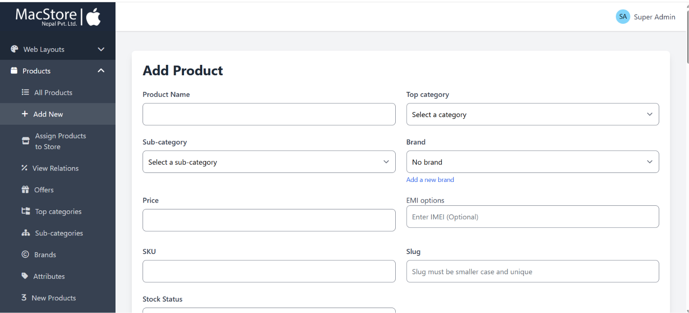
Fig: New product Creation Section
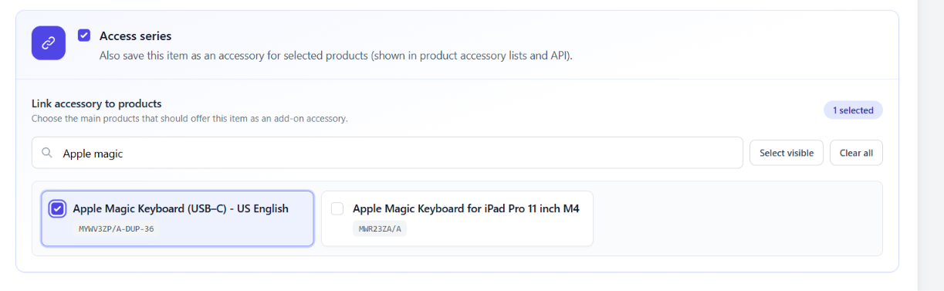
Fig: Assign the product as accessories (admin)
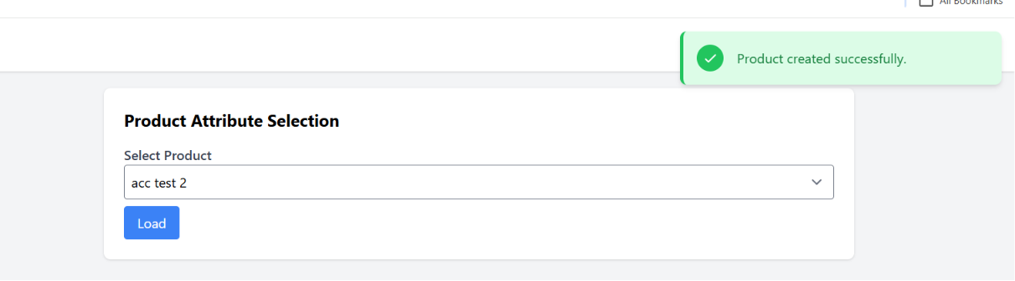
Fig: product created successfully (admin)
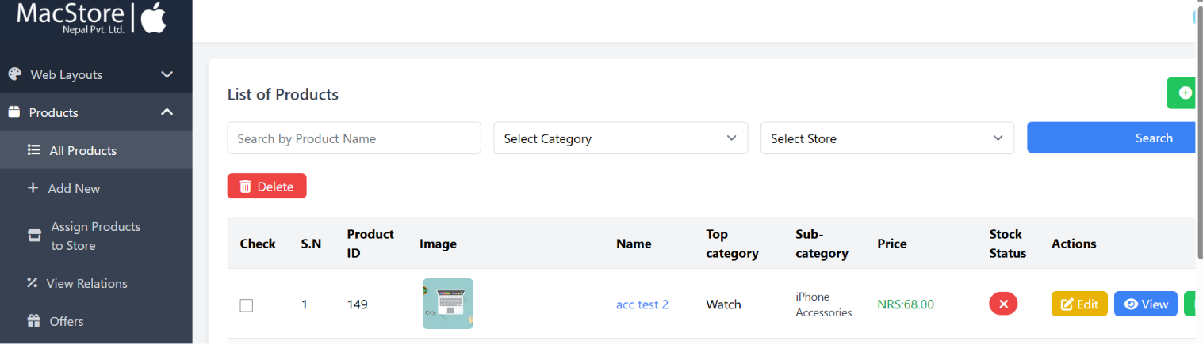
Fig: Product get created and viewing in all product (admin)
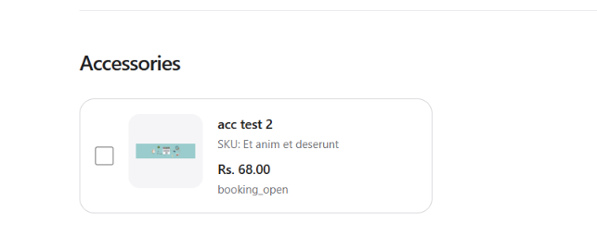
Fig: Product is listed as accessories of another product (Client)
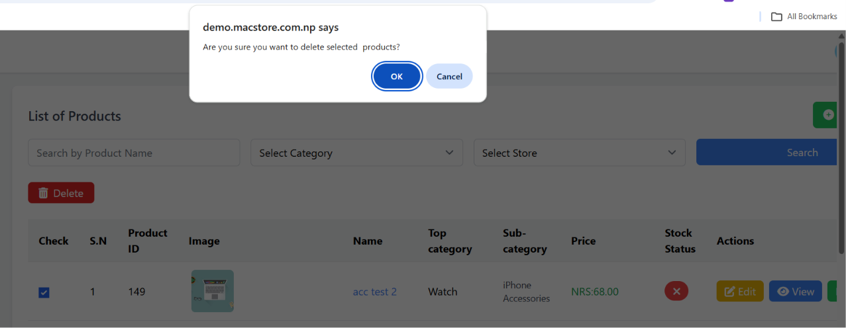
Fig: Deleting the product (admin)
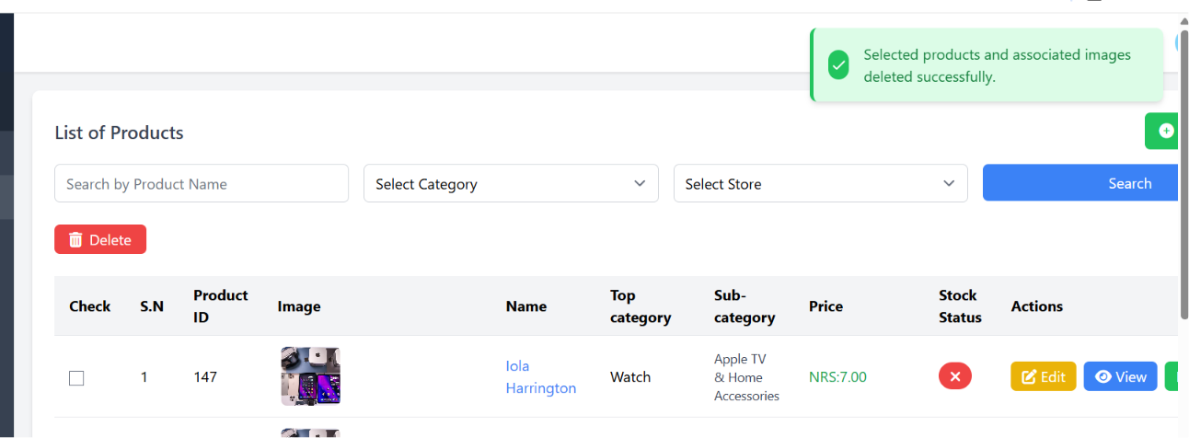
Fig: Product got deleted (admin)
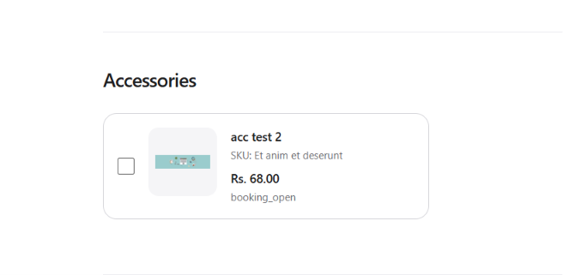
Fig: product getting still viewed as accessories
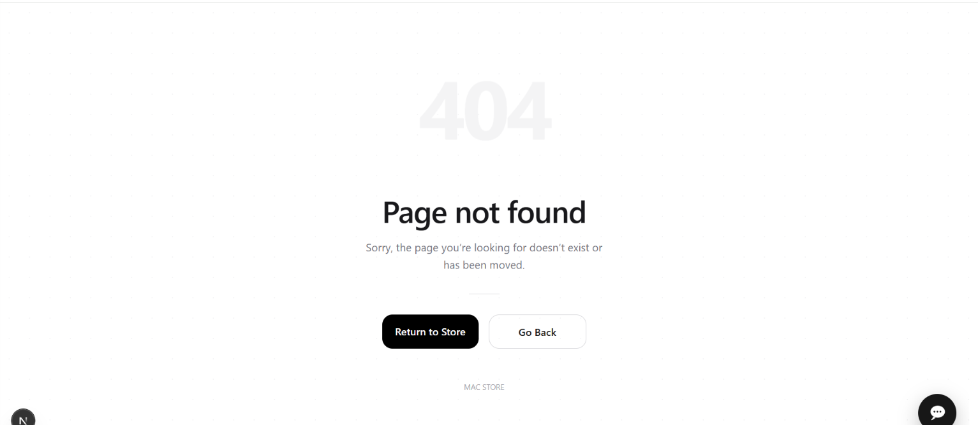
Fig: Clicking the accessories product
Note: since it is not present in the product table page not found occurs

Steps to Reproduce
- Create a new product.
- During product creation, assign it as an accessory to an existing product.
- Verify that the accessory appears under the selected product.
- Delete the newly created accessory product.
- Open the product to which the accessory was assigned.
Expected Result
- The deleted product should no longer appear in the assigned accessories.
- Any accessory relationship referencing the deleted product should be removed automatically or excluded from retrieval.
Actual Result
- The product is successfully removed from the product list.
- The deleted product continues to appear in the assigned accessories of another product.
Possible Root Cause
The accessory relationship stored in the accessories (or mapping) table is not being deleted or validated when the related product is removed. This leaves orphaned records that reference products that no longer exist in the active product list.
Impact
- Inconsistent product data.
- Administrators see deleted products as valid accessories.
- Potential errors when editing or displaying accessory information.
- Increased risk of data integrity issues over time.
Recommended Solution
- Remove accessory relationships when a product is deleted (cascade delete or application-level cleanup).
- Validate accessory references while retrieving data to ensure deleted products are excluded.
- Review foreign key constraints and relationship handling to maintain referential integrity after product deletion.

